Predicting Visual Search Efficiency Using Eye-Tracking Data
RAVICHANDER JANPATI
PROFESSOR, SCHOOL OF CSE &AI
SR UNIVERSITY
WARANGAL, TELANGANA,506371, INDIA
ravichander.j@sru.edu.in
AJAY PANAGANTI
CSE
SR UNIVERSITY
WARANGAL, TELANGANA,506371, INDIA
2403a510b4@sru.edu.in
NARIGE PRUDHVI
CSE
SR UNIVERSITY
WARANGAL, TELANGANA,506371, INDIA
2403A510G7@sru.edu.in
ALLA SREEMANTH REDDY
CSE
SR UNIVERSITY
WARANGAL, TELANGANA,506371, INDIA
2403A510G1@sru.edu.in
JAMANJYOTHI ABHIRAM
CSE
SR UNIVERSITY
WARANGAL, TELANGANA,506371, INDIA
2403a511342@sru.edu.in
MD.RAHEL
CSE
SR UNIVERSITY
WARANGAL, TELANGANA,506371, INDIA
2403A510E2@sru.edu.in

Abstract— Visual search is a fundamental task in Human-Computer Interaction (HCI), where users interact with digital interfaces to locate relevant information efficiently. Understanding gaze behavior provides valuable insights into user attention and usability. This paper presents a system for predicting visual search efficiency using eye-tracking data. The proposed approach analyzes gaze coordinates, fixation duration, and scanpaths to model user attention patterns. Heatmaps are generated to visualize areas of interest, and scanpath analysis is used to understand navigation behavior. A machine learning model based on linear regression is employed to predict gaze positions. Additionally, efficiency metrics such as fixation count, average fixation duration, and scanpath length are computed. The results demonstrate that gaze-based analysis can effectively improve user interface design and information visualization.

Keywords— Human-Computer Interaction, Eye Tracking, Visual Search, Heatmap, Scanpath, Machine Learning, UI Design.

INTRODUCTION

Human-Computer Interaction (HCI) focuses on designing efficient and user-friendly systems. A key aspect of HCI is understanding how users visually interact with interfaces. Visual search refers to the process of locating a target among multiple elements on a screen.
Traditional usability evaluation methods, such as surveys and manual observation, fail to capture real-time user attention. Eye-tracking technology provides precise data about gaze position, fixation duration, and eye movement patterns.
This paper proposes a system that analyzes eye-tracking data to predict visual search efficiency. By generating heatmaps, scanpaths, and predictive models, the system helps understand user behavior and improve interface design.

PROBLEM STATEMENT
Despite advancements in interface design, many digital systems still suffer from poor usability due to a lack of understanding of user attention and visual behavior. Traditional evaluation techniques do not provide detailed insights into how users interact with visual elements in real time.
The key problem addressed in this work is:
- How to analyze user gaze behavior effectively using eye-tracking data
- How to measure visual search efficiency quantitatively
- How to predict gaze patterns using computational models
There is a need for a system that can process eye-tracking data, generate meaningful visualizations such as heatmaps and scanpaths, and compute efficiency metrics to improve user interface design.
.
DESCRIPTION OF THE DATASET
This study uses a dataset from Kaggle that has information about eye tracking.
The dataset has:
Images of the eye taken in different situations
Coordinates for the gaze (x, y positions)
Data on eye movement and position
METHODS
- DATASET DESCRIPTION

A. Dataset Description

The dataset consists of eye-tracking records containing:

X and Y gaze coordinates

Fixation duration

.Sequential gaze points

B. DATA PREPROCESSING
The dataset is cleaned by removing missing values. Gaze coordinates are normalized:
$$x_{norm}=\frac{x}{1920},y_{norm}=\frac{y}{1080}$$
C. Heatmap Generation
A heatmap is generated by mapping gaze points onto a 2D grid. Each point increases pixel intensity, and Gaussian blur is applied to smooth the visualization.
Heatmaps highlight regions where users focus most.
It's a quick, visual way to get what grabs attention. With heatmaps, you can spot which parts of the interface matter most, which ones users barely notice, and where people might feel lost or confused.
D. SCANPATH ANALYSIS

Scanpaths represent the sequence of gaze movements. By plotting normalized coordinates, the system visualizes how users navigate through the interface.

E. Machine Learning Model

A Linear Regression model is used:
- Input: X-coordinate
- Output: Y-coordinate
The dataset is split into training (80%) and testing (20%) sets. The model is evaluated using Mean Squared Error (MSE).

F. Efficiency Metrics

The following metrics are calculated:
- Fixation Count – Total gaze points
- Average Fixation Duration – Time spent per fixation
- Scanpath Length – Total eye movement distance
$$Scanpath Length=∑\sqrt{\left(x_{i+1}-x_{i})^{2}+(y_{i+1}-y_{i})^{2}\right.}$$
Shorter scanpaths indicate more efficient visual search.

IMPLEMENTATION
- • The whole system is implemented using Python in a development environment such as Jupyter Notebook or Google Colab.
- • The implementation consists of data processing, visualization, and basic machine learning tasks.
- • The following libraries and tools are used:
- – NumPy is used for numerical computations and array operations.
- – Pandas is used for loading, cleaning, and processing the eye-tracking dataset.
- – Matplotlib is used to generate visualizations such as heatmaps, scanpaths, and prediction graphs.
- – Seaborn is optionally used to enhance data visualization and improve graphical representation.
- – OpenCV is used for image processing, specifically for applying Gaussian blur to generate smooth heatmaps.
- – Scikit-learn is used to implement the Linear Regression model for predicting gaze coordinates.

RESULTS AND DISCUSSION

The results give a clear look at how users interact with the interface:

Fig. 1. Gaze Heatmap Showing User Attention Distribution:

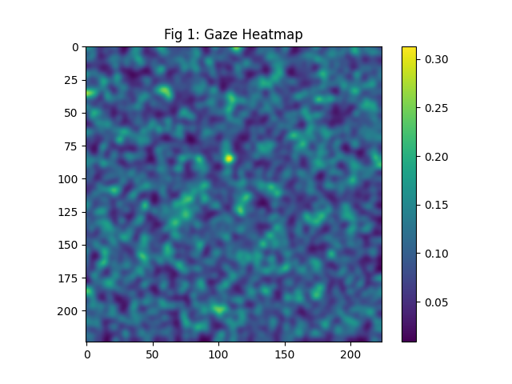

As shown in Fig. 1,represents the gaze heatmap generated from the eye-tracking dataset. The heatmap visualizes the distribution of user attention across the interface by mapping gaze points to pixel intensity values.

Regions with higher intensity (warmer colors) indicate areas where users focused more frequently, while lower intensity regions represent less attention. The application of Gaussian blur smooths the distribution, making attention patterns more visible and continuous.

This visualization helps in identifying:

Frequently viewed interface components

Areas of high user engagement

Regions that may require design improvement

Overall, the heatmap provides a clear representation of visual attention concentration and is useful for optimizing UI layout.

Fig. 2. Scanpath Visualization Representing Eye Movement Sequence.
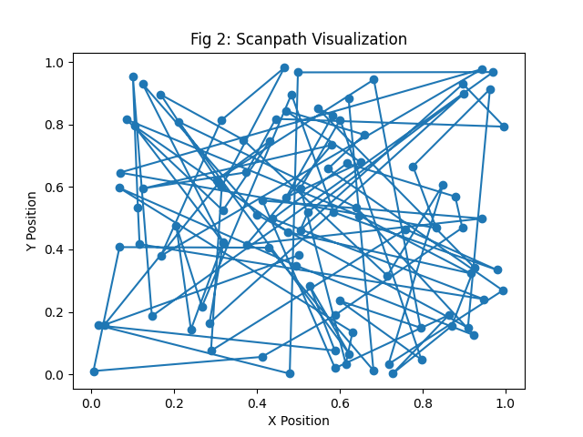

Fig. 2:shows the scanpath visualization, which represents the sequence of eye movements made by the user during the visual search task. Each point corresponds to a fixation, and the connecting lines illustrate the transition between successive gaze points.
The scanpath reveals the navigation pattern of the user across the interface. A shorter and more direct scanpath indicates efficient visual search behavior, while a longer or scattered scanpath suggests difficulty in locating the target.
This visualization helps in:
- Understanding user navigation flow
- Identifying inefficient search patterns
- Evaluating cognitive effort during interaction
Thus, scanpath analysis provides valuable insights into how users visually explore and interact with the interface.

APPLICATIONS
The proposed system can be applied in several areas:
- UI/UX design to improve interface layout and usability
- Web design optimization for better user engagement
- Information visualization to highlight important data regions
- Usability testing and user behavior analysis
- Accessibility improvements for better user interaction

ADVANTAGES

The system offers the following advantages:
- Provides accurate analysis of user attention using gaze data
- Simple and easy-to-implement approach
- Generates clear visual outputs such as heatmaps and scanpaths
- Helps in improving UI/UX design decisions
- Can be extended for real-time and advanced applications

Limitations

• Simple model (Linear Regression)

• Limited dataset

• No deep learning implementation
Future Work
- Deep learning models (CNN, LSTM)
- Real-time systems
- Advanced saliency models

CONCLUSION

This paper presents a system for predicting visual search efficiency using eye-tracking data by analyzing gaze behavior through heatmaps, scanpaths, and machine learning techniques. The results show that heatmaps effectively identify areas of high attention, while scanpaths reveal user navigation patterns.

Efficiency metrics such as fixation count, average duration, and scanpath length help in evaluating user performance. The findings indicate that efficient visual search is associated with shorter and more direct gaze paths.

Overall, the proposed system provides a simple and effective approach for understanding user behavior and improving user interface design.

REFERENCES

[1] Kaggle Eye Tracking Dataset

[2] Research papers on Eye Tracking and HCI

[3] Online resources on accessibility

Acknowledgment
We want to say a heartfelt thank you to Dr. Ravichander Janapati, our Course Coordinator at SR University. His guidance, support, and encouragement made a real difference as we worked through this project. His insights helped us finish strong.

We’re also grateful to SR University for all the resources and the supportive environment that let us dive into our research. Thanks to the faculty and our peers—they were always ready with help and honest feedback when we needed it.

And of course, a big shout-out to the open-source datasets and tools that powered our research from start to finish.

IEEE conference templates contain guidance text for composing and formatting conference papers. Please ensure that all template text is removed from your conference paper prior to submission to the conference. Failure to remove template text from your paper may result in your paper not being published.

